West Virginia Psychiatric Association Winter Meeting February 5, 2021

Virtual Meeting using Zoom platform

Agenda:

12:00 pm – 12:15 pm Welcome/Announcements

12:15 pm – 2:30 pm Three Case Presentations
(objectives attached)

“Psychosis and Suicidal Ideation in a College Student”
Presented by: Matthew Lemberger, MD, Marshall University

“Dysphoric Milk Ejection Reflux: Case Presentation Discussing
What it is, How it is Treated, and Why it is Important”
Presented by: Schlyer Kidd, DO, WVU Charleston

“A Case of Psychosis in a Patient with Severe Neurologic Deficits”
Presented by: Daniel Leonor, MD, WVU Morgantown

2:30 – 2:45 pm – Break
2:45 – 4:30 pm – Business Meeting

Please RSVP by January 29, 2021 to Barbara A. Samples at wvdbpsych@frontier.com or call 304-776-5067

You must RSVP in order to receive the Zoom link to join the meeting

WE LOOK FORWARD TO SEEING YOU THERE!

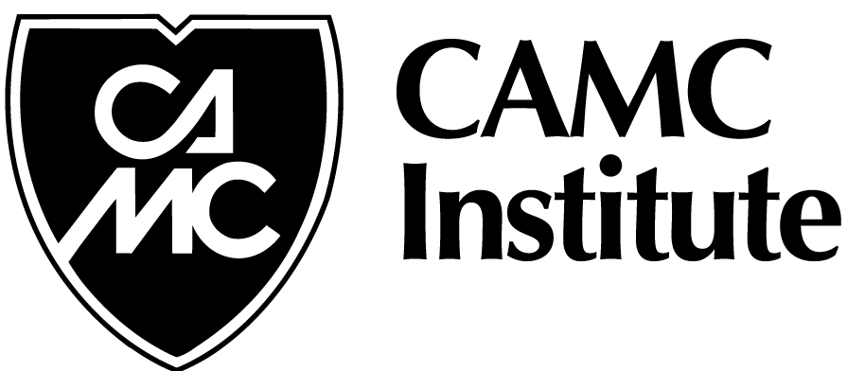

Disclosure
It is the policy of the CAMC Health Education and Research Institute that any faculty (speaker) who makes a presentation at a program designated for AMA Physician’s Recognition Award (PRA) Category I or II must disclose and financial interest or other relationship (i.e. spouses/partners, grants, research support, consultant honoraria) that faculty member has with the manufacturer(s) of any commercial product(s) that may be disclosed in the educational presentation. Program Planning Committee Members must also disclose any financial interest or relationship with commercial industry that may influence their participation in this conference.
Accreditation: In support of improving patient care, this activity has been planned and implemented by The West Virginia Psychiatric Association and CAMC Health Education and Research Institute. CAMC Health Education and Research Institute is jointly accredited by the Accreditation Council for Continuing Medical Education (ACCME), the Accreditation Council for Pharmacy Education (ACPE), and the American Nurses Credentialing Center (ANCC), to provide continuing education for the healthcare team.
Physicians- CAMC Health Education and Research Institute’s CME program is accredited by the Accreditation Council for Continuing Medical Education to sponsor continuing medical education for physicians. CAMC Health Education and Research Institute designates this live activity for a maximum of 2.25 AMA PRA Category I credit(s)™. Physicians should only claim credit commensurate with the extent of their participation in this activity.

